房源信息

一、可租赁房源89套

|  |  |  |  |  |  |
| --- | --- | --- | --- | --- | --- |
| **位置** | **序号** | **楼栋** | **房间号** | **套内面积(m2)** | **备注** |
| 一区  （25套） | 1 | 156栋 | 304 | 67.27 |  |
| 2 | 156栋 | 308 | 67.27 |  |
| 3 | 156栋 | 311 | 67.27 |  |
| 4 | 158栋 | 002 | 48.18 |  |
| 5 | 158栋 | 003 | 48.18 |  |
| 6 | 158栋 | 005 | 48.18 |  |
| 7 | 158栋 | 006 | 48.18 |  |
| 8 | 158栋 | 007 | 48.18 |  |
| 9 | 158栋 | 101 | 47.14 |  |
| 10 | 158栋 | 102 | 47.14 |  |
| 11 | 158栋 | 105 | 47.14 |  |
| 12 | 158栋 | 106 | 47.14 |  |
| 13 | 158栋 | 107 | 47.14 |  |
| 14 | 158栋 | 108 | 47.14 |  |
| 15 | 158栋 | 109 | 47.14 |  |
| 16 | 158栋 | 111 | 47.14 |  |
| 17 | 158栋 | 201 | 47.14 |  |
| 18 | 158栋 | 203 | 47.14 |  |
| 19 | 158栋 | 204 | 47.14 |  |
| 20 | 158栋 | 207 | 47.14 |  |
| 21 | 158栋 | 209 | 47.14 |  |
| 22 | 158栋 | 210 | 47.14 |  |
| 23 | 158栋 | 212 | 47.14 |  |
| 24 | 158栋 | 310 | 47.14 |  |
| 25 | 158栋 | 311 | 47.14 |  |
| 二区  （4套） | 26 | 226栋 | 212 | 76.21 |  |
| 27 | 228栋 | 207 | 96.73 |  |
| 28 | 230栋 | 112 | 95.90 |  |
| 29 | 230栋 | 109 | 95.90 |  |
| 四区  （60套） | 30 | 439栋 | 101 | 47.14 |  |
| 31 | 439栋 | 104 | 47.14 |  |
| 32 | 439栋 | 106 | 47.14 |  |
| 33 | 439栋 | 112 | 47.14 |  |
| 34 | 439栋 | 201 | 47.14 |  |
| 35 | 439栋 | 202 | 47.14 |  |
| 36 | 439栋 | 203 | 47.14 |  |
| 37 | 439栋 | 204 | 47.14 |  |
| 38 | 439栋 | 209 | 47.14 |  |
| 39 | 439栋 | 210 | 47.14 |  |
| 40 | 439栋 | 211 | 47.14 |  |
| 41 | 439栋 | 212 | 47.14 |  |
| 42 | 439栋 | 301 | 47.14 |  |
| 43 | 439栋 | 302 | 47.14 |  |
| 44 | 439栋 | 309 | 47.14 |  |
| 45 | 439栋 | 310 | 47.14 |  |
| 46 | 439栋 | 311 | 47.14 |  |
| 47 | 439栋 | 312 | 47.14 |  |
| 48 | 439栋 | 401 | 47.14 |  |
| 49 | 439栋 | 402 | 47.14 |  |
| 50 | 439栋 | 412 | 47.14 |  |
| 51 | 440栋 | 103 | 47.14 |  |
| 52 | 440栋 | 108 | 47.14 |  |
| 53 | 440栋 | 202 | 47.14 |  |
| 54 | 440栋 | 206 | 47.14 |  |
| 55 | 440栋 | 207 | 47.14 |  |
| 56 | 440栋 | 211 | 47.14 |  |
| 57 | 440栋 | 212 | 47.14 |  |
| 58 | 440栋 | 301 | 47.14 |  |
| 59 | 440栋 | 306 | 47.14 |  |
| 60 | 440栋 | 307 | 47.14 |  |
| 61 | 440栋 | 308 | 47.14 |  |
| 62 | 440栋 | 310 | 47.14 |  |
| 63 | 440栋 | 311 | 47.14 |  |
| 64 | 440栋 | 312 | 47.14 |  |
| 65 | 440栋 | 404 | 47.14 |  |
| 66 | 440栋 | 405 | 47.14 |  |
| 67 | 440栋 | 410 | 47.14 |  |
| 68 | 440栋 | 411 | 47.14 |  |
| 69 | 440栋 | 412 | 47.14 |  |
| 70 | 445栋 | 101 | 60.70 |  |
| 71 | 445栋 | 103 | 60.70 |  |
| 72 | 445栋 | 104 | 60.70 |  |
| 73 | 445栋 | 112 | 60.70 |  |
| 74 | 445栋 | 113 | 60.70 |  |
| 75 | 445栋 | 206 | 60.70 |  |
| 76 | 445栋 | 207 | 60.70 |  |
| 77 | 445栋 | 209 | 60.70 |  |
| 78 | 446栋 | 109 | 60.70 |  |
| 79 | 446栋 | 111 | 60.70 |  |
| 80 | 446栋 | 112 | 60.70 |  |
| 81 | 446栋 | 113 | 60.70 |  |
| 82 | 447栋 | 112 | 96.49 |  |
| 83 | 450栋 | 114 | 91.93 |  |
| 84 | 450栋 | 214 | 91.93 |  |
| 85 | 451栋 | 211 | 91.93 |  |
| 86 | 452栋 | 06 | 73.27 |  |
| 87 | 452栋 | 07 | 73.27 |  |
| 88 | 452栋 | 09 | 73.27 |  |
| 89 | 452栋 | 12 | 73.27 |  |

二、部分参考户型图

**（一） 158栋户型图（47.14㎡）**

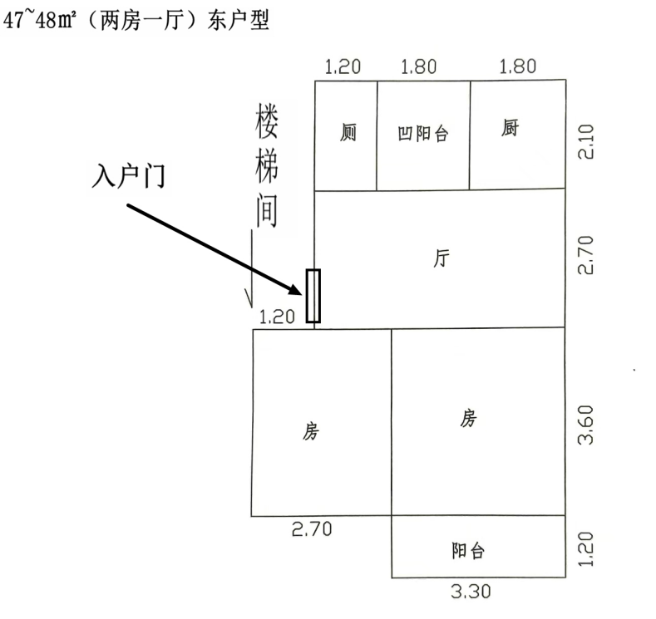

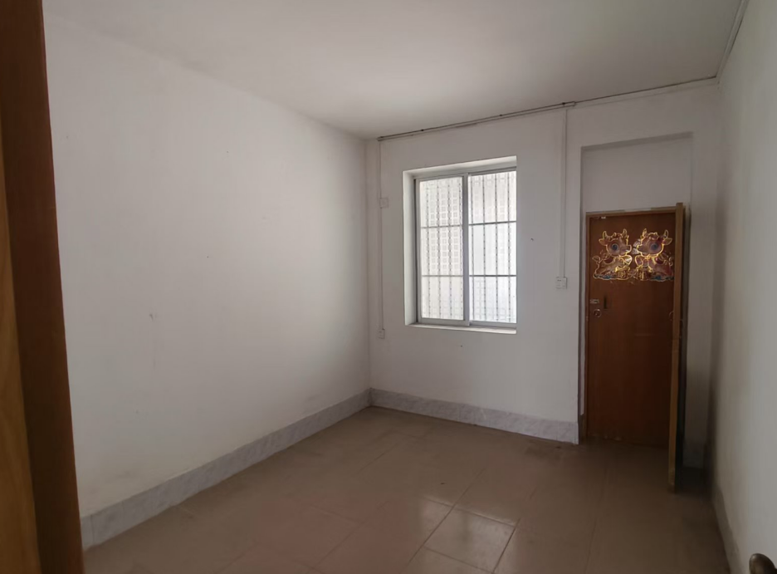

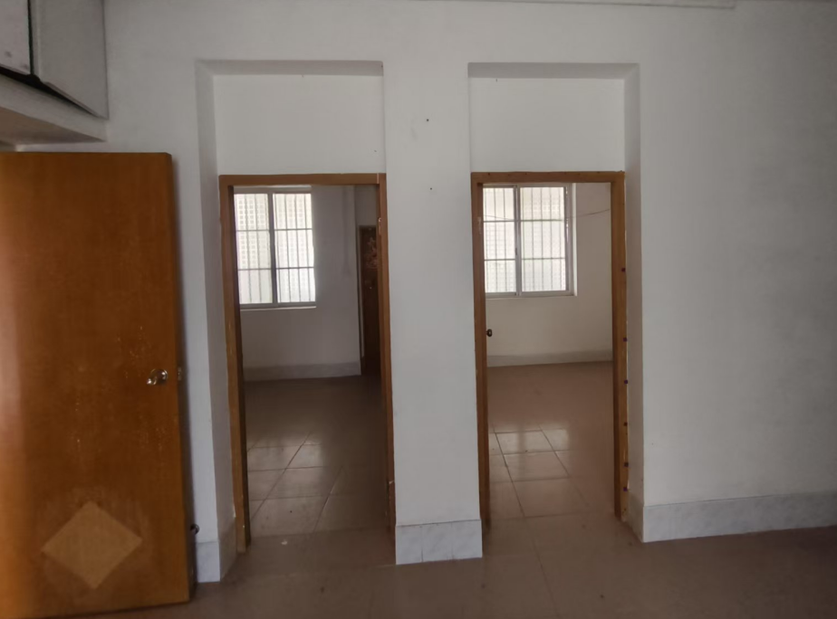

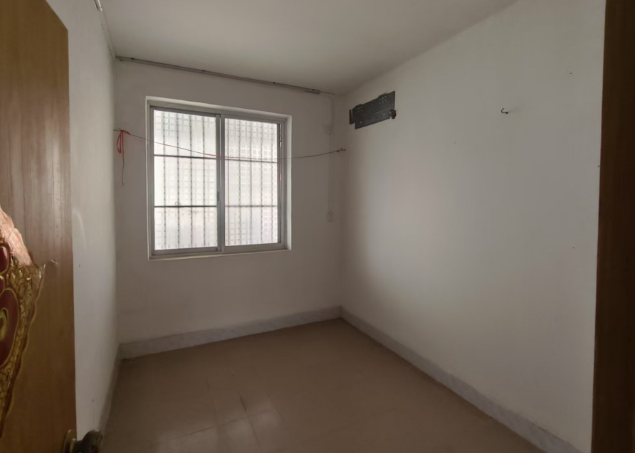

**（二）156栋户型图（67.27㎡）**

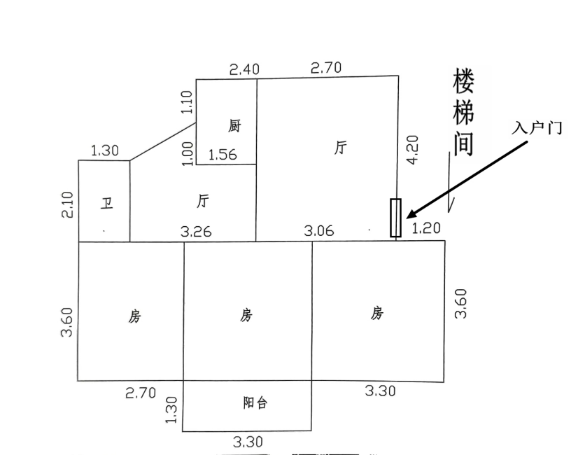

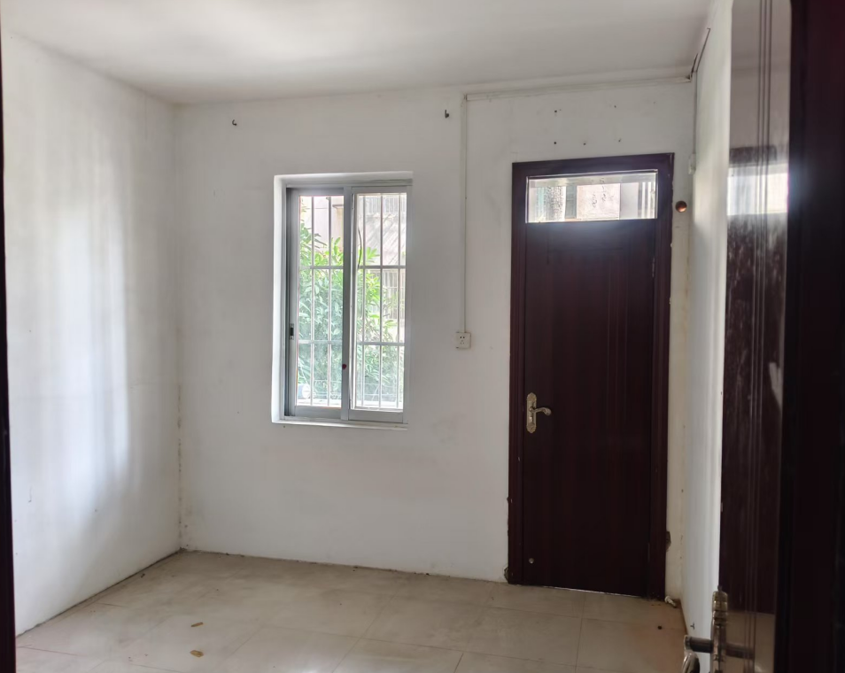

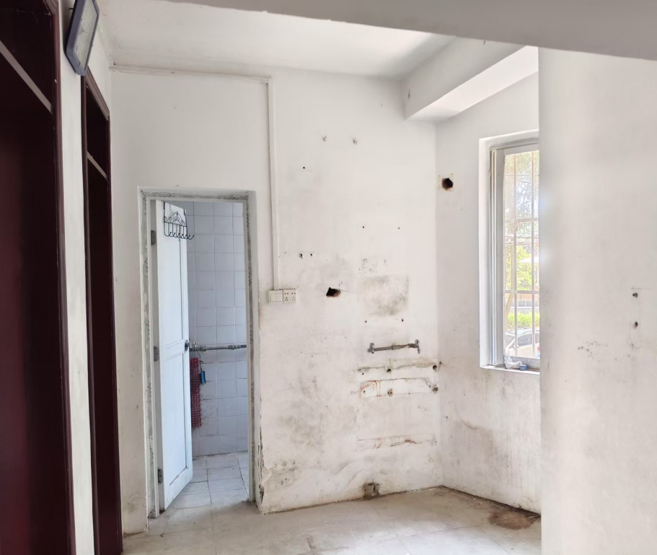

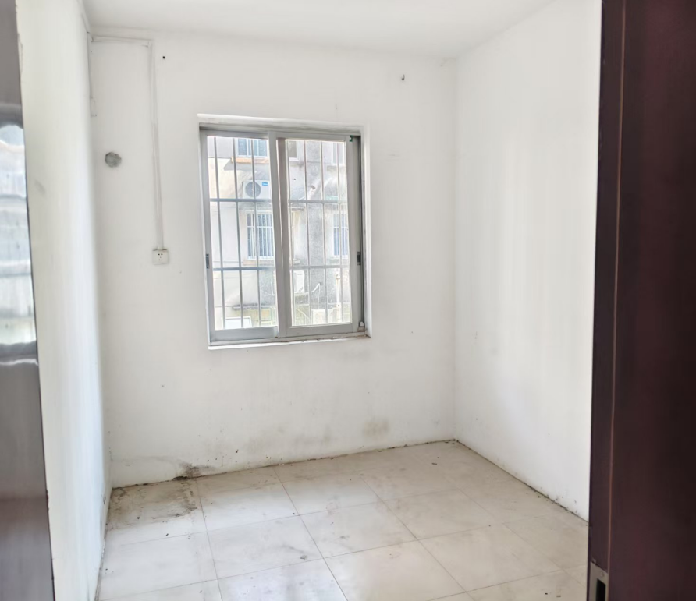

**（三）448栋户型图（77.62㎡）**

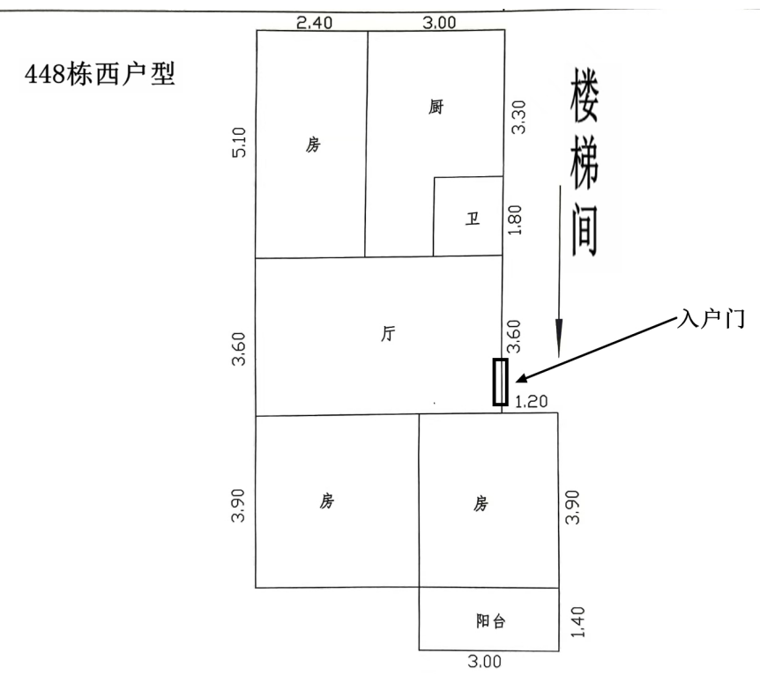

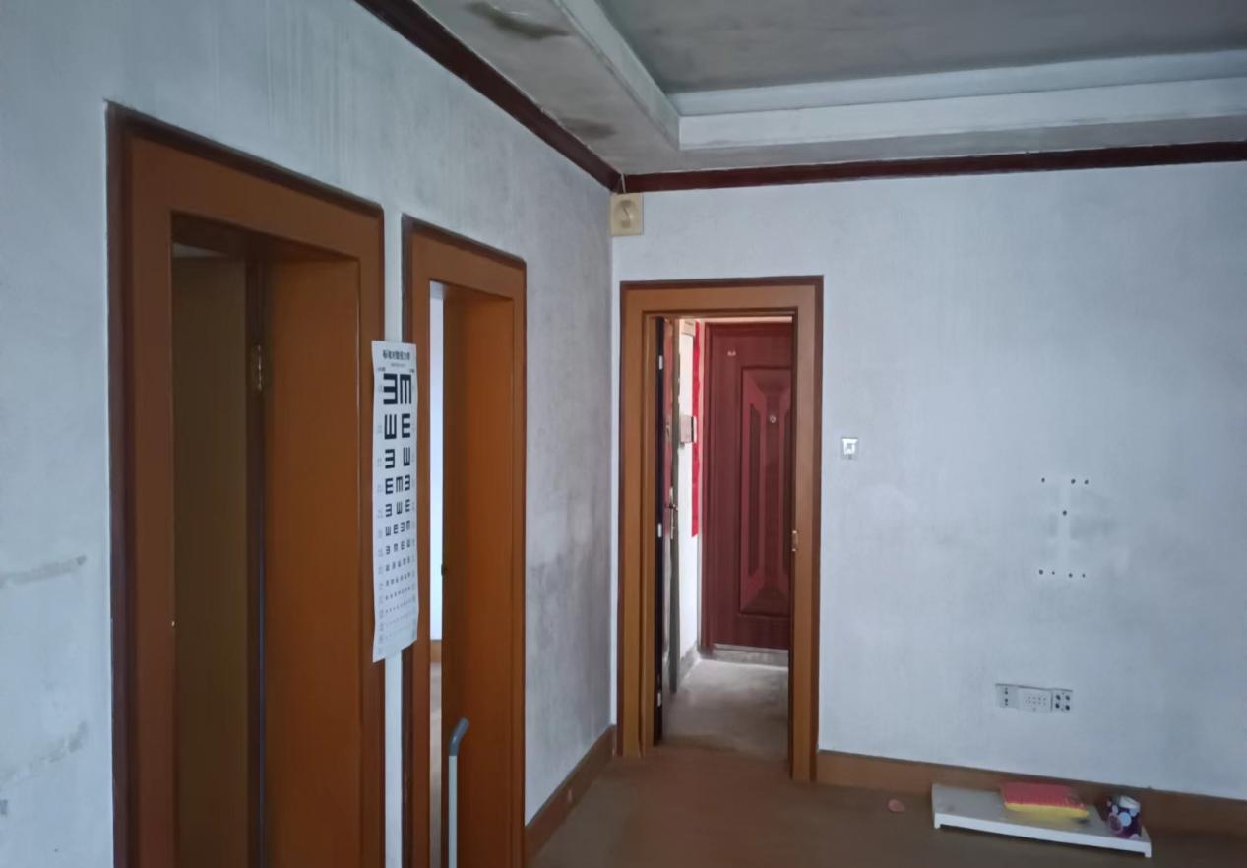

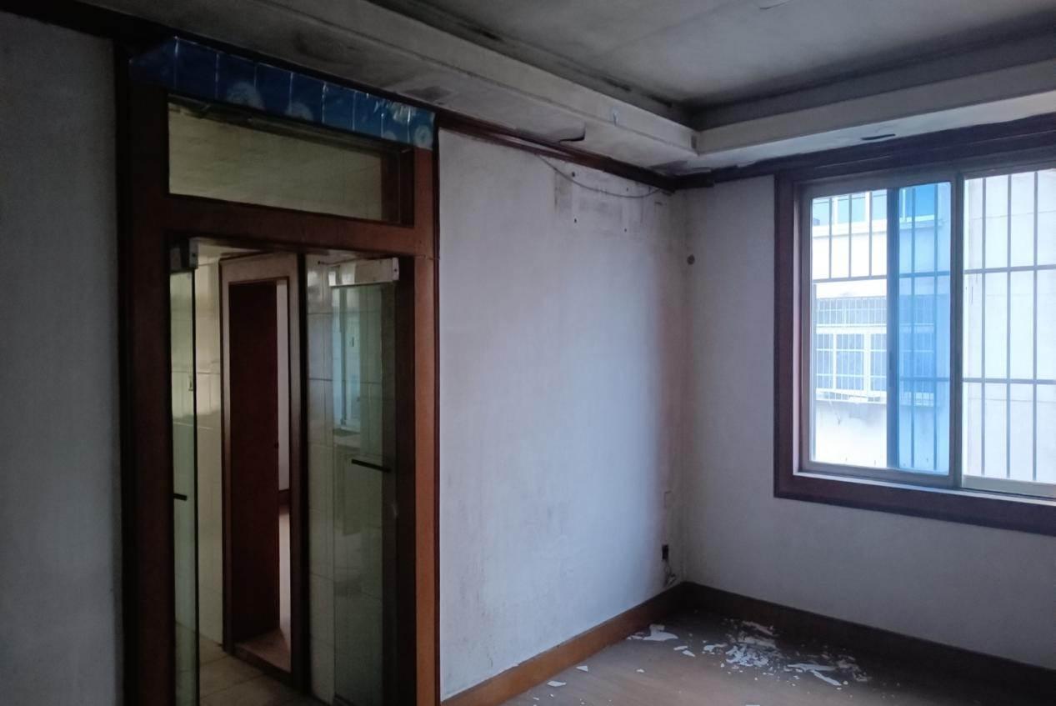

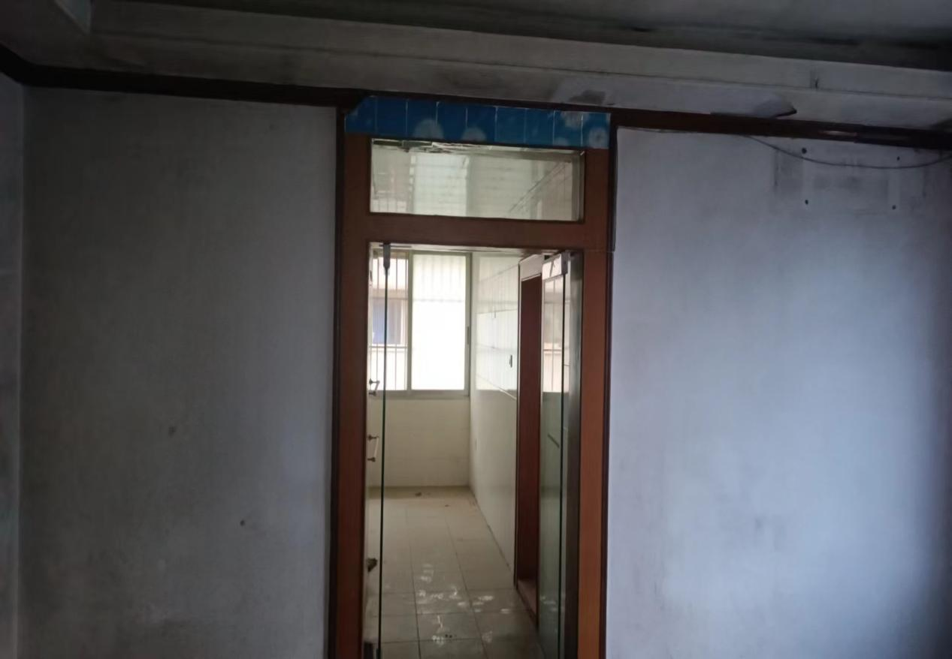

**（四）230栋户型图（95.9㎡）**

